SCHOOL VERIFICATION CHECKLIST

SCHOOL INTERVIEW/DISCUSSION GUIDE

Name of school: ………………………………………………………………………………..

1a | Does the Facility have a record of all assets provided under UgIFT.  (Obtain a record and verify if it has the costs and numbers supplied | No
1b | If Not ask how many were supplied and when.

2 | How does this facility Maintain (repair/service/replace) the assets provided under Ugift  - Minor maintenance such as cleaning, servicing, simple repairs and replacement of basic parts is done by the facility staff using the maintenance percentage on the grant

3 | Does the facility take regular record about functionality/ or breakdown of the assets provided?  Nonfunctional/ working, and reasons for non-functionality. | - YES  - They have a notebook where they record the functionality of the assets

4 | How has the UgIFT support helped in service delivery in the area, any issues, challenges and any recommendations for better program implementation. | BENEFITS  - Staff residence. The UGIFT program has provided accommodation to some Mpiita Seed teachers hence making them available 24/7 to provide the necessary services to the learners  - Furniture. The program has provide desks, shelves, chairs, etc this facilitating the smooth running of the school  - Facility infrastructure. UGIFT has constructed buildings ie the lab, library, classrooms and others. This has made it easy for the facility to managed the increasing number of learners at the facility  CHALLENGES  - No sign post at the facility. This made it difficult for the verification team(us) to locate the facility  - Unconstructed pitch. This has hindered the implementation of the new CBC at the facility  - Incomplete library building. The library exists but insecure due to the fact that it lacks the burglary proof  - No internet installed or at the facility  - Incomplete staff kitchen with a leaking roof  - No fence. The facility is not fenced thus making it complicated to control the learners  - No water source. The facility lacks a water source for both the learners and the staff  - No furniture in the main hall. Special furniture is needed in the examination hall  RECOMMENDATIONS  - Consider fencing the facility.  - Construct the pitch to enable the implementation of the CBC  - Consider putting a sign post in place.  - Provide a reliable drinking water at the facility

PROCEED TO VERIFICATION AFTER THIS DISCUSSION

SCHOOL FURNITURE
(School Desks, Office chairs, Laboratory stools, Book shelves)

Name of LG : BUGWERI DISTRICT
Name of SCHOOL: MPIITA SEED SECONDARY

Equipment/ Item | Department | Item  Description | Life in Months | Tag Number ( engrave no.) | Date Of Pur | Date Placed In Service | Recoverable cost | Cost | Acc Dep Cost | Net Book Value | Ytd Deprn | Equipment status | Remarks
School Desks | education | Long Brown wooden with black metallic stands and a shelve for books |  | Engraved  MPT 0 EED |  |  |  |  |  |  |  |  | 120 received  110 verified and in use
Leaners chair | education | Brown single sitter square woolen chair with 4 metallic |  | Engraved  MPT/CH/74/25 |  |  |  |  |  |  |  |  | 233 verified out of the 240 and 7 broken
Office tables | education | Wide wooden brown table with a cabinet |  | Engraved  MPT SEED SCH |  |  |  |  |  |  |  |  | 10 received, verified and in use
tables | education | Wide wooden brown table with a cabinet |  | Engraved  MPT SEED SCH |  |  |  |  |  |  |  |  | 128 received , verified and all in use
Lab stools | education |  |  | MPT SEED SCH |  |  |  |  |  |  |  |  | 112 verified and all in use
Book shelves | education | Wooden in nature, wall mounted with gray metals while others are built on the wall with compatibles |  | Not Engraved

ICT ITEMS TO VERIFY
(Desktop Computer, Server Processor, Network Switch 24 Port, Multipurpose Printer, UPS, Projector, Air Conditioners, Server, CCTV Camera)

Name of LG : BUGWERI
Name of SCHOOL: MPIITA SSS

Equipment/ Item | Department | Item  Description | Life in Months | Tag Number ( engrave no.) | Date Of Pur | Date Placed In Service | Recoverable cost | Cost | Acc Dep Cost | Net Book Value | Ytd Deprn | Equipment status | Remarks
Desktop Computer, | education | Lenovo  Desktop  Computer  set –  Centre tower  with Lenovo  monitor,  keyboard &  mouse |  | MPT/5/03/25 |  | 05/25/2025 |  | 83,300,000 |  |  |  | functioning | 21 received and all in use
Network Switch 24 Port | education |  |  | Not engraved |  | 05/25/2025 |  | 3,500,000 |  |  |  |  | Not received
Multipurpose Printer | education | Multipurpose  Printer – Print  /Copy/  Scan for  education  office |  | Engraved  MPT/PRINT/O1/25 |  | 05/25/2025 |  | 5,200,000 |  |  |  | functioning | 1 received, verified and in use
CCTV Camera | education | A typical CCTV  Camera  Mounted on  The wall |  | Not engraved |  | 05/25/2025 |  | 2,400,000 |  |  |  |  | Received but not installed
UPS | education | Black UPS  Lenovo  Computers  and server |  | Engraved  MPT/5/14 |  | 05/25/2025 |  | 10,000,000 |  |  |  |  | 20 received,  19 verified and in use
Air Conditioners | education | Black Air  Conditioner  for Computer  Lab / Server  room |  |  |  | 05/25/2025 |  | 6,000,000 |  |  |  |  | 1 received
Lan | education | Local Area  Network  (LAN)  Installation /  Cabling  And  Networking  points for  office  internet  connectivity |  | Not engraved |  | 05/25/2025 |  | 18,000,000 |  |  |  |  | Not received and not verified
router | education | Network Router  for internet  distribution  and LAN  management |  | Not engraved |  | 05/25/2025 |  | 2,500,000
Internet connection | education | Internet  Connectivity  Service /  Installed  internet  line and  configuration  for office use |  |  |  | 05/25/2025 |  | 6,960,000 |  |  |  |  | Not verified
Server ups | education | Black  Uninterruptible  Power Supply  (UPS) for  Server –  Power |  | Not engraved |  | 05/25/2025 |  | 1,500,000 |  |  |  |  | Not verified
Server processor | education | Black  Server Central  Processing  Unit (CPU)  Main Server |  | Not engraved |  | 05/25/2025 |  | 8,500,000 |  |  |  |  | Not verified

BUILDINGS TO VERIFY
(Non- Residential and Residential, Kitchen, Toilets/Pit latrine Water tanks, Fences etc.)

Name of LG: BUGWERI DISTRICT
Name of SCHOOL: MPIITA SSS

Equipment/ Item | Department | Item  Description | Life in Months | Tag Number ( engrave no.) | Date Of Pur | Date Placed In Service | Recoverable cost | Cost | Acc Dep Cost | Net Book Value | Ytd Deprn | Equipment status | Remarks
Classroom blocks |  | 2 blocks with 3 classes on each. Painted coffee brown and yellow |  | Not engraved |  | 2021/2022 |  | 435,355,650 |  |  |  | functional | 2 blocks, verified and in use
Laboratory block |  | 1 block painted coffee brown and yellow |  | Not engraved |  | 2021/2022 |  | 286,459275 |  |  |  | functional | 1 block verified and in use
Administration block |  | 1 block painted coffee brown and yellow |  | Not engraved |  | 2021/2022 |  | 169,125,275 |  |  |  |  | I building verified and in use
Staff quarters |  | 2 unit teachers house with 2 rooms on each |  | Not engraved |  | 2021/2022 |  | 467,144,850 |  |  |  |  | Verified and in use
Staff kitchen |  | 2 unit staff kitchen painted coffee brown and yellow |  | Not engraved |  | 2021/2022 |  | 120,358,725 |  |  |  |  | Verified and in use
Staff toilets |  | 2 stance lined toilets painted coffee brown and yellow |  | Not engraved |  | 2021/2022 |  | 77,825,820 |  |  |  |  | Verified and in use
ADM Toilets |  | 1 stance painted coffee brown and yellow |  | Not engraved |  | 2021/2022 |  | 20,146,300 |  |  |  |  | Verified and in use
Boy latrines |  | 5 stance toilets  painted coffee brown and yellow |  | Not engraved |  | 2021/2022 |  | 38,631,440 |  |  |  |  | Verified and in use
Girls toilets |  | 5 stance toilets painted coffee brown and yellow |  |  |  | 2021/2022 |  | 38,963,500 |  |  |  |  | Verified and in use
Water tank |  | 500ltank  Black in color and a small one raised on metallic stands |  | Not engraved |  | 2021/2022 |  | 8,473,000 |  |  |  |  | Verified and in use
Library block |  | 1 library block painted coffee brown and yellow |  | Not engraved |  | 2021/2022 |  | 381,467,430 |  |  |  |  | Verified and in use
Hall |  | 1 Main Hall painted coffee brown and yellow |  | Not engraved |  | 2021/2022 |  | 259,413875 |  |  |  |  | Verified and in use
Sports field |  | Not done |  | Not engraved |  | 2021/2022 |  | 50,000,000 |  |  |  |  | Verified and in use

ASSET VERIFICATION BRIEF REPORT
NAME OF THE SCHOOL: MPIITA SSS,

CONDUCTED BY
WANDERA SOLOMON AND KIYUBA SALIMU
Introduction.
This brief report presents the findings of the physical asset verification exercise conducted at MPIITA SSS. The team was warmly welcomed by the deputy head teacher since the head teacher was not available.
Findings.
- Key assets including all medical assets, furniture and buildings were physically verified and found present.
- All the items were found to be functional and in good physical condition.
- The school has no fence.
- No water reliable power
- No reliable drinking water source for learners

- Inadequate text books
- Inadequate staff accommodation
- One power meter serving the entire facility making the consumption of the purchased power units untrackable

Challenges.
- The school has no sign post
- The respondents took a lot of time to arrive and attend to us

Recommendation.

- We highly recommend the construction of a reliable drinking water source for the learner
- A sign post should be put on place as soon as possible
- Consider construction of more staff quarters to accommodate and retain critical staff for effective 24hr service delivery.

Conclusion.
The asset verification exercise was successfully completed with full staff from the Deputy Head Teacher . All critical assets were verified, are functional, in good condition and well handled.

MPIITA SEED SECONDARY SCHOOL

PhysicalVerification Pictures.

The table below illustrates some physical status of the verified assets with photographic evidence for MPIITA SEED SECONDARY SCHOOL
Physical verification photos
MPIITA SSS COMPUTER LAB  NOT ENGRAVED | 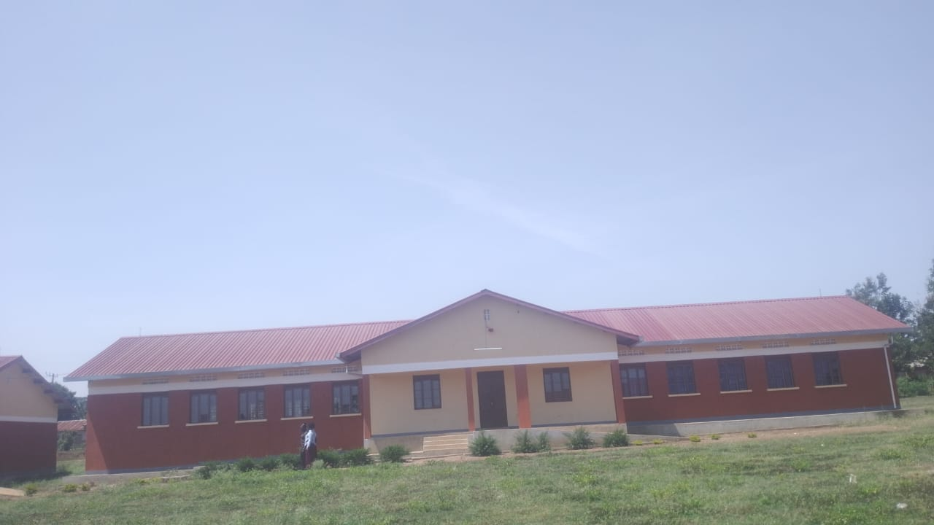
MPIITA SSS ADMINISTRATION BLOCK | 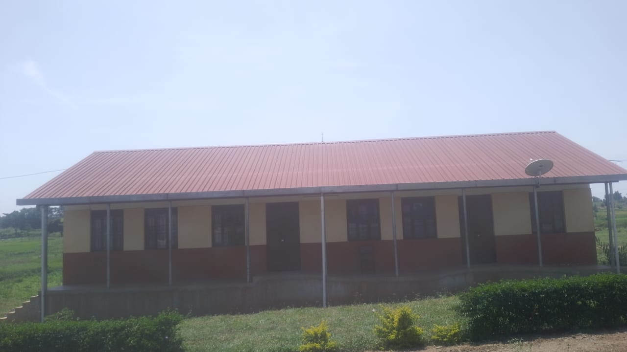
SCIENCE LAB  NOT ENGRAVED | 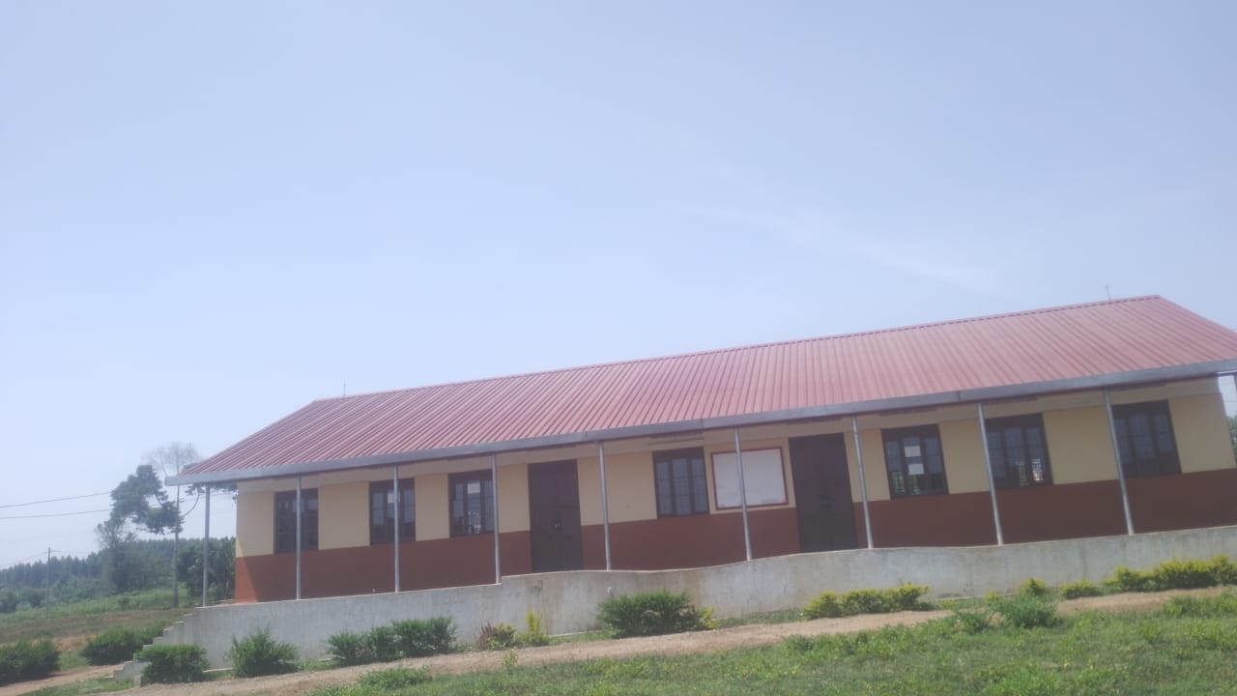
CLASS ROOMS  NO TENGRAVED | 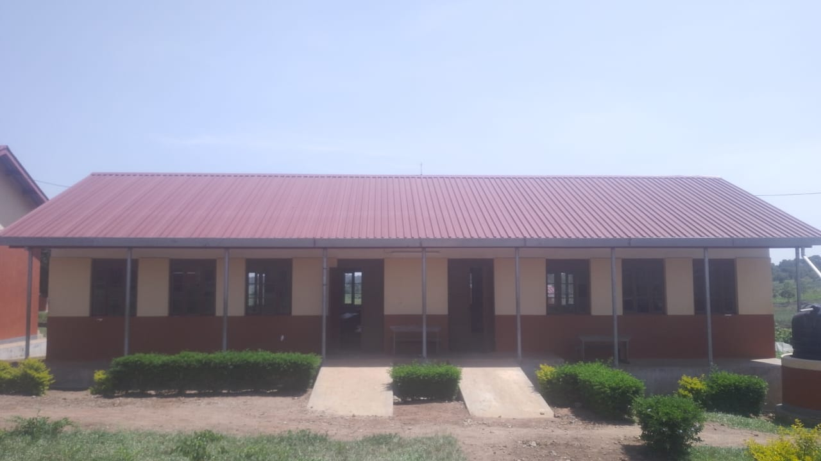
5 STANCE TOILETS FOR THE LEARNERS  NOT ENGRAVED | 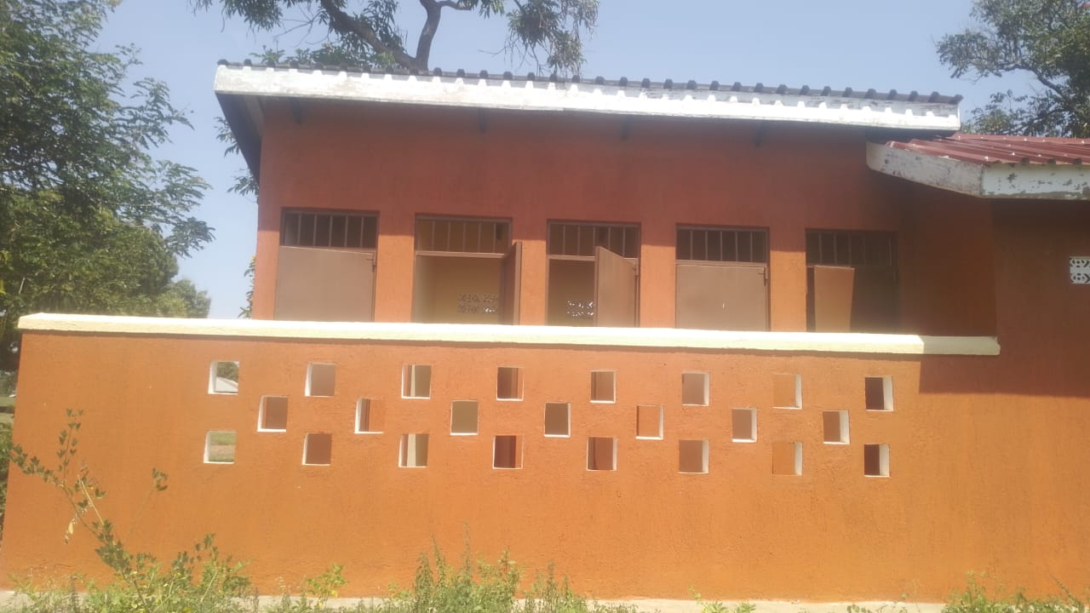
4 STANCE TOILETS FOE LEARNERS | 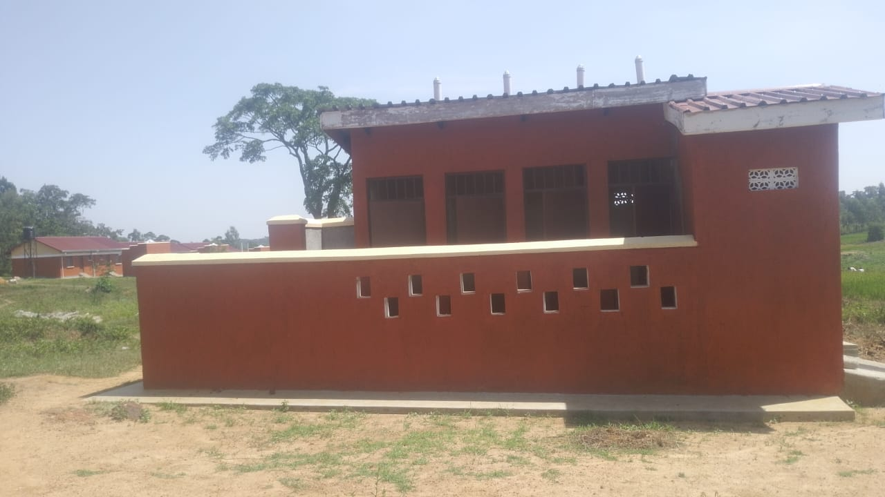
2 STANCE STAFF TOILETS  NOT ENGRAVED | 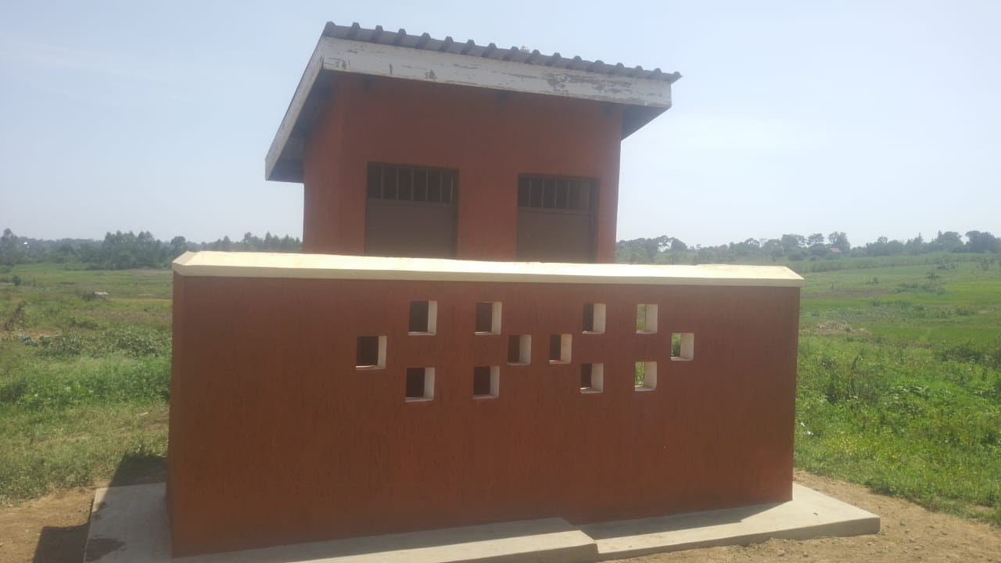
STAFF QUARTER  NOT ENGRAVED | 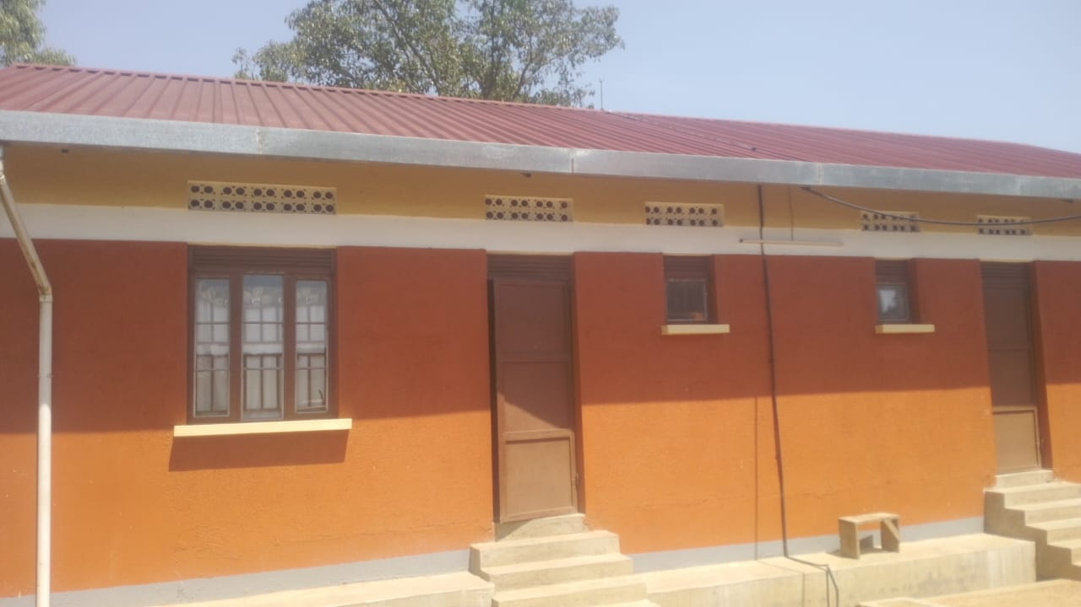
STAFF KITCHEN
NOI ENGRAVED
DESKS  ENGRAVED  “MPT SEED SCH” | 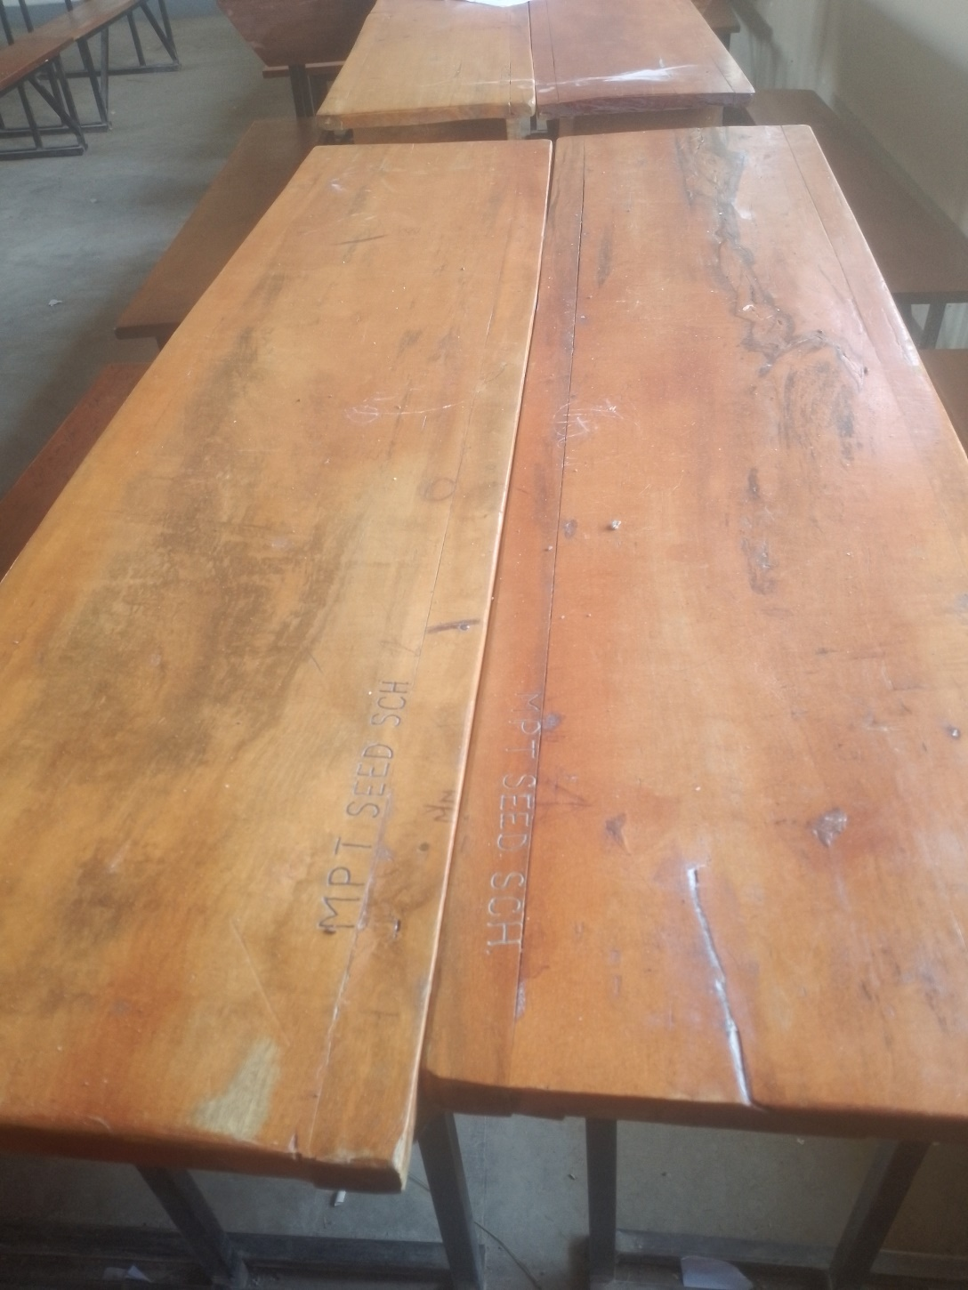
A SAMPLE OF CHAIRS ENGRAVEMENT FORMAT | 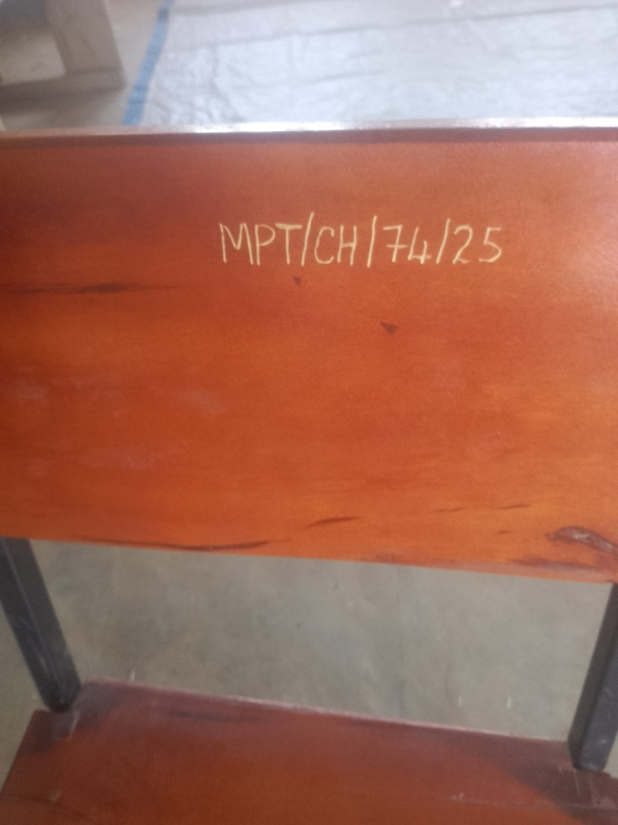
ENGRAVED  CHAIRS | 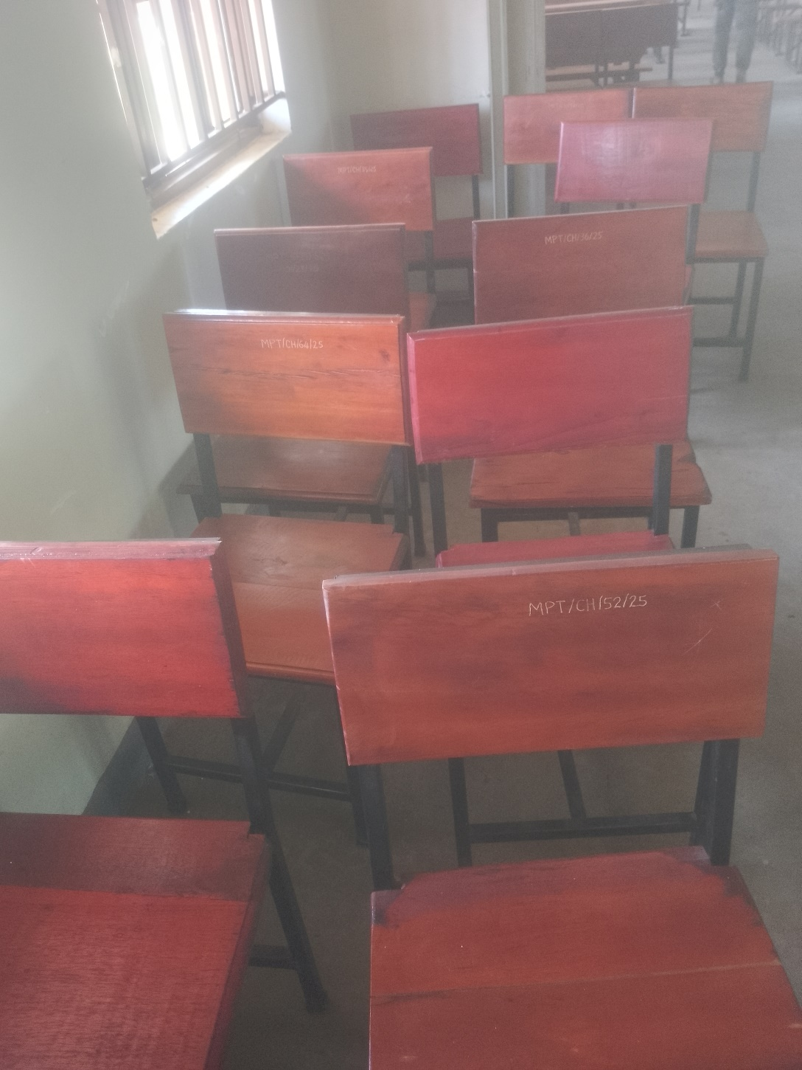
TABLES  ENGRAVED  “MPT SEED SCH” | 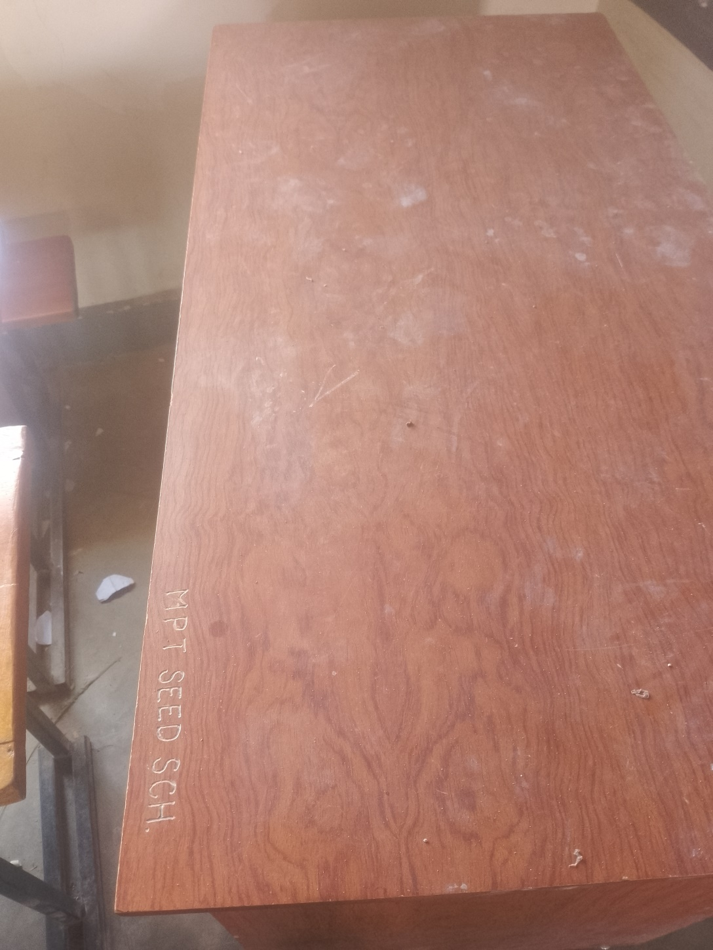
BOOK SHELVES  NOT ENGRAVED | 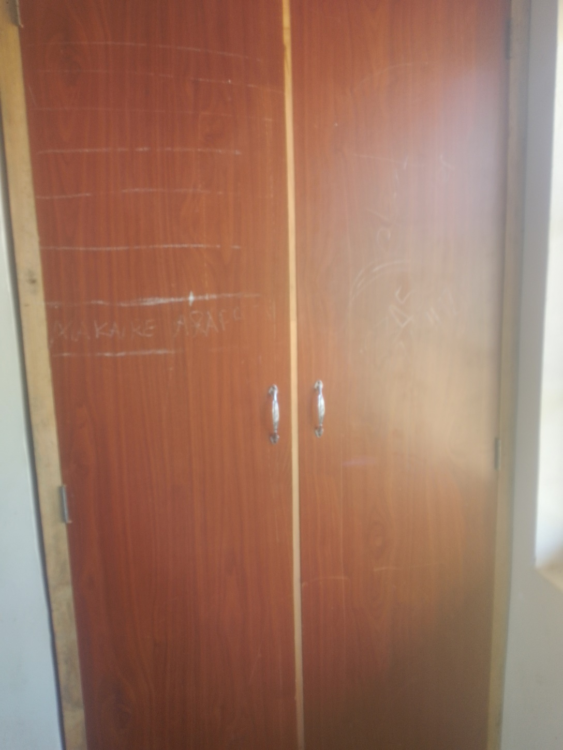
DESKTOP COMPUTER  ENGRAVED  “MPT/5/03/25” | 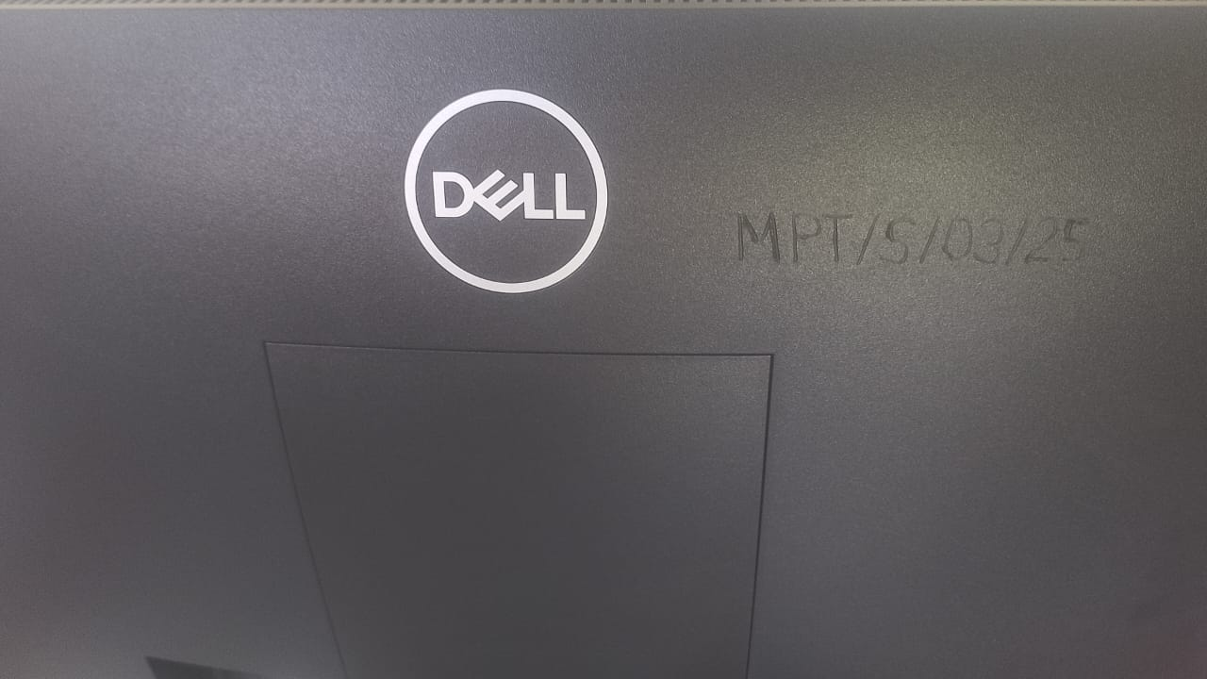
MULTI-PURPOSE PRINTER  ENGRAVED “MPT/PRINT/01/25” AND FUNCTIONING | 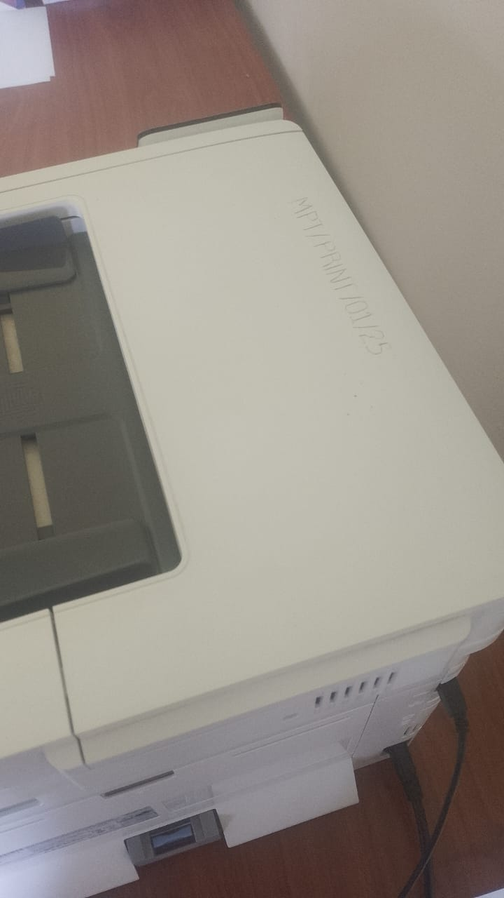
A BIG TANK ON A CIRCULAR CONCRETE AND A SMALL ONE RAISED ON 4 METALLIC STANDS  NOT ENGRAVED | 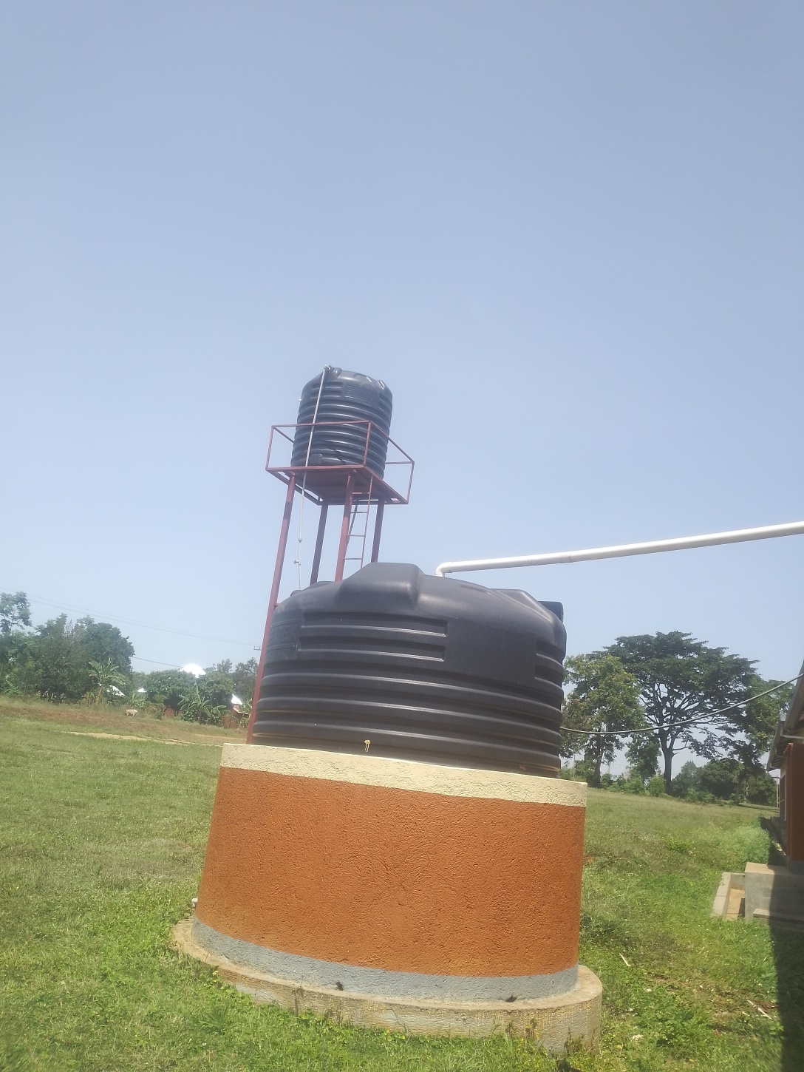
50,000,000M PITCH  (NOT DONE) | 